**Sources and References**

* Navigation Bar Inspiration from the w3Schools example

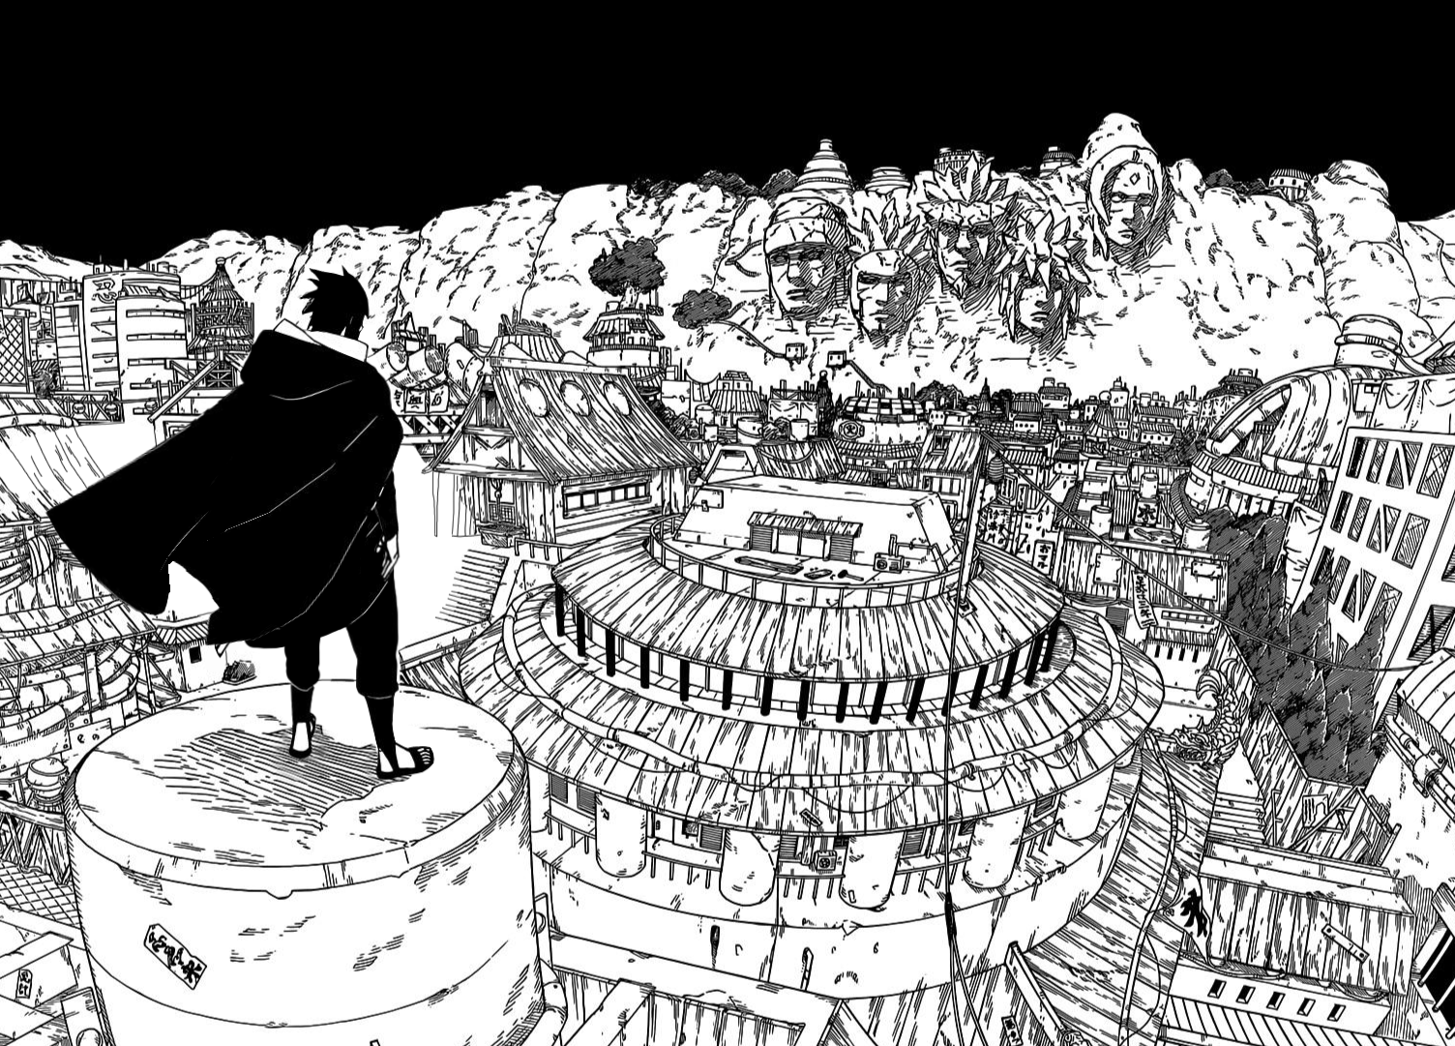

^ Source: “Naruto” Chapter 618

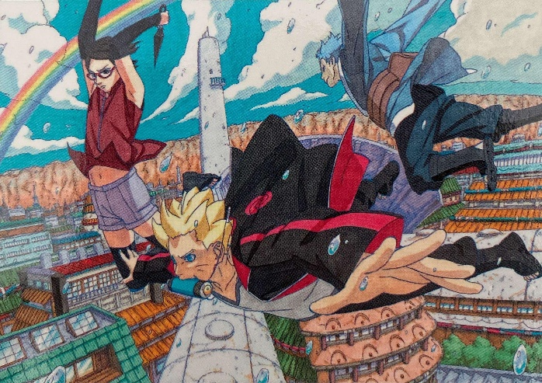

^ Source: Masashi Kishimoto

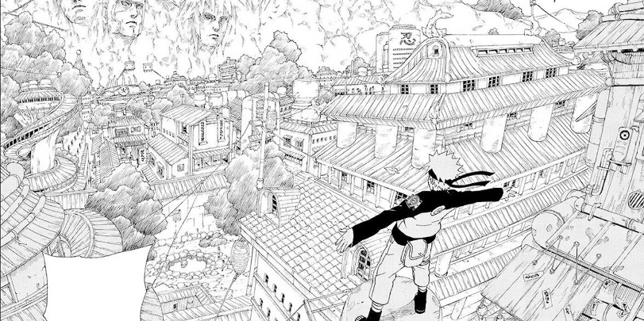

^ Source: “Naruto” Chapter 245

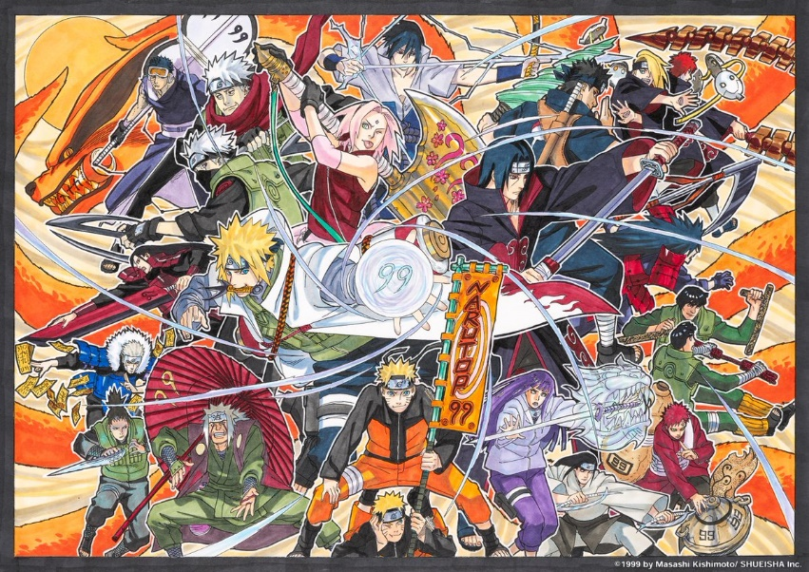

^ Source: Masashi Kishimoto

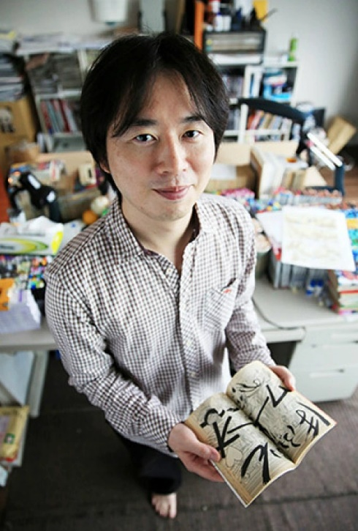

^ Source: <https://wikinetworth.com/celebrities/masashi-kishimoto-net-worth-married-wife-religion.html>

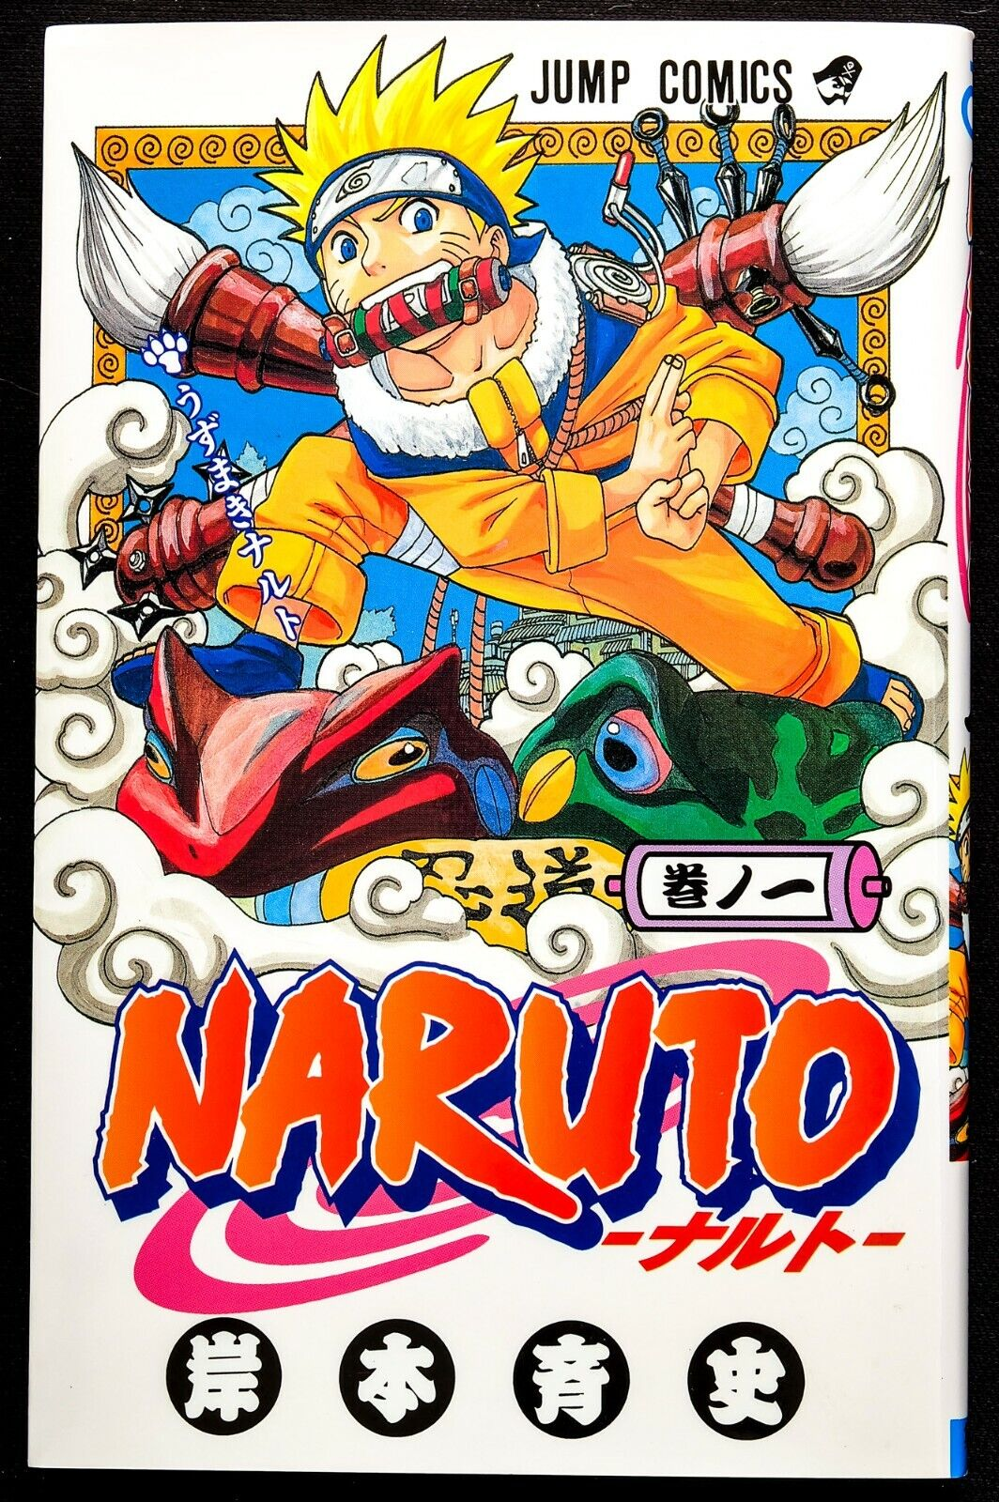

^ Source: “Naruto” Volume 1 Front Cover



^ Source: https://en.wikipedia.org/wiki/Kyushu_Sangyo_University